Idle Workers at Mosaic Cafe

# Isaiah Sarria, Josmar Garcia, Owen Telis, Michael Farrelly, Jasmine Williams

## 

## Professor Griselle Centeno

## December 12, 2021

**Objective**

One of the current issues at Florida Polytechnic’s Mosaic Cafe are the long lines that occur in between classes. This often causes students to be late to class, or to decide to not get anything. This causes a loss of profit for the cafe, as well as places a strain onto the employees. The subject of this case will be the Mosaic Cafe, and how efficient it currently runs. Our goal is to identify possible elements within the work environment that may slow the workers down, or anything else that may cause them to not be as efficient with their jobs. If it is found that the Mosaic Cafe is truly inefficient, then certain measures to help productivity have to take place. Possible solutions include more workers, another machine capable of making drinks, or a second cash register.

The current elements of this case are the amount of people in line, and how many staff members are present that are actively working versus them being idle. A staff member is classified as “working” if they are visibly working on a task such as working the register, stocking, making a drink, etc. They are considered idle if they are simply standing there. As long as they are working, they are classified as efficient. The more efficient they are, the quicker they can serve customers. Since most of the rush occurs during lunchtime in between classes, it is actually expected for them to be idle for about 80% of the day. It is to be expected that during the time in between classes that the line is longer than 5 students 15% of the time, and another 5% of the time for anything less.

The allotted amount of error is chosen to be +/-10%, given how long the idle times will be and how the randomly generated observation times may actually skew the data rather than choosing more specific times of anticipated traffic. The confidence level will be 95%, and the accuracy level will be 5%. Given this, and the large idle time, the number of observations needed for the study will be roughly 60. There will be 12 random observations during the course of a 5-day period, starting the moment they open (7:30 AM), until the moment they close (4:00 PM).

**Theory**

The goal of the project would be to prove that the cafe isn’t as efficient as it can be currently. To prove this, the study needs to begin by finding the amount of observations, the random times needed to sample, and analyze the data. Figuring out the number of observations is an important first step. The number of observations is found out with an equation that is derived from the Z-alpha value, halved then squared, multiplied by the probability of idle time, 1 minus the probability of the idle time, all divided by the error squared. The number of observations is important as they are entirely derived from the confidence level that has been decided on.

To determine the confidence interval in the first place, is to make the assumption of how confident you want the data to be. On the standard deviation graph, most of the data points may appear within the 95% confidence level, while any outlier may fall in the outside region of the alpha-half area. The alpha-half area helps determine the true probability, as it would just be 1 minus those smaller areas. For this case, alpha is 0.05, meaning alpha half will be 0.025. The Z-alpha-half value (pre-determined from a Z-score table) will be 1.96.

Establishing the value of sigma will help us check the original probability against the new value and can see how it compares. Depending on the trend, the original probability may end up being wrong entirely and would mean that the original probability that was theorized may have been wrong.

**Procedure**

The first step of the process was to figure out the problem at hand, and then find a way to conduct the study. As the line at the cafe is an issue that has affected the students on campus, that became an easy study to focus on. The very next step was to determine the amount of observations needed. With the confidence level set at 95%, alpha came out to be 0.05. The Z-alpha-half value for this confidence level will be 1.96. Our error is 10%. We chose 10% to account for the possibility of the cafe not being as busy as initially thought for the study. With the idle time probability (p) being 80%, the q (1-p) value will be 20%. With these values known, the number of observations can be found to be roughly 62. However, over the course of five days, it would be more sensible to split the daily observations by 12 to have the same amount of observations daily with a total amount of 60 observations.

With the number of observations known, the next step was to determine the random times to take said observations. Using Excel, a random number generator function was utilized to give random numbers in a range of times, and then converted to give a more exact time within the time frame.

During the process of collecting data, we determined what days and times data needed to be collected in order to collect truly random data. We decided to collect data between 7:30 AM - 4:00 PM for five days at the Mosaic Cafe because that is their time of operations. While collecting data, we were simply counting the amount of people in line compared to the amount of people working. The number of people working was broken down even further by the number of workers actually working and the workers who were standing idle.

**Data Analysis**

Given the data recorded, we found the sum-total observed number of workers and the number of idle workers. By dividing idle workers by total numbers of workers for each day, we are able to find the actual proportion in which the workers were idle. The gray line on the graph is the upper control limit, the orange line is the lower control limit, and the yellow line is the assumed proportion of idle workers. To find sigma: square root((p * q)/n). Where ‘p’ is the assumed percentage of idle workers, ‘q’ is 1 minus ‘p’, and ‘n’ is the total number of observations taken. Then with the sigma level, we find the upper and lower control limits by plus/minus 3 sigma.

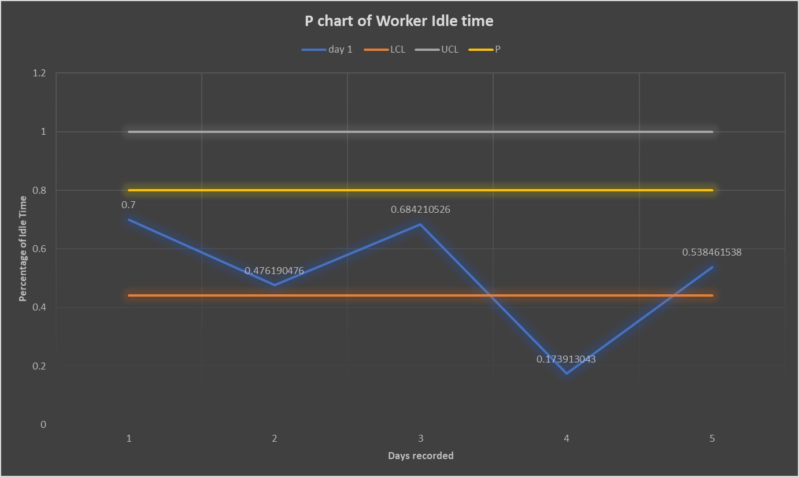

**Figure 1: Control Chart**

Given the data from the P chart, it is found that the original probability of idle time that was estimated turned out to be incorrect and too high. For the amount of days that were being observed, the actual probability of the workers being idle turned out to be much lower than previously anticipated. On day 4 specifically, the probability of idle time came out to be 17%. This was out of control, and therefore solidifies that the original assumption was incorrect. The other values that still were in control appeared below the 80% line, so this was another indicator of the idle time probability being incorrect. It shows that the workers are actually more efficient than previously thought and are working more than was anticipated.

If the study were to be redone with a lower probability that better reflects the probability of the total idle time of about 50%, while also keeping the original confidence level and error, then the new number of observations would be 97. This would help the study have better results. The 50% idle time would potentially reflect better on the overall time, in contrast to the current control chart (where idle time is estimated to be 80%), would be better.

On each of the five observed days, we estimated how much time all the workers spent idle by dividing the observed occurrences of workers being idle by the total number of observations that day. Then, one minus the newly found fraction provides the portion of the day workers are spent not idling. Multiplying the fraction of workers working by 8 (the number of hours the cafe is open) then by 60 (to convert the value to minutes), we then took the minutes and divided it by 100, which is an estimate of how many orders are served on the given day. The average of these five observed estimates is 2.34 minutes. We assumed two things: a performance rating of 90% and an allowance factor of .09. With these two assumptions, and the calculated average observed time, we were able to compute both normal time and standard time.

**Table 1**

|  |  |  |
| --- | --- | --- |
| Avg. Observed Time spent working w/ customer | Normal Time spent working w/ customer | Standard Time spent working w/ customer |
| 2.34 minutes | 2.196 minutes | 2.106 minutes |

**Recommendations**

Given the data, the best recommendation to make would be to keep the current amount of workers. The idle time currently isn’t as bad as initially thought, and so there is no need to improve their efficiency further. They appear to be efficient enough on most days. There may actually be a need for more workers depending on the time of day or add another register to generally process more transactions but based on current data that may not be known currently.

For the study itself, it is recommended to go use the new number of observations found previously. This would potentially yield better overall results that can better reflect the actual amount of time the workers are idle. The new study would then have a more accurate understanding of the actual problem at hand as well.